In this report, we will describe the development of the assignment in each stage using Jasse James Garrentt methodology. This methodology drives us through five planes it providing a way for talking about UX problems and the tools we use to solve them.

We start with the plain lowest (less abstract) until the last plane (more concrete) for understand the development of an excellent user experience and all the elements that contains detail to detail. Each plane is dependent on the planes below it and each one has its itself process of construction.

**The Strategy Plane:**

First, we made a research of the users that will use the system and we were raised goals for the realization of this work based in the needs of the users.

We made an UX questionnaire for collect all the information about the users that will use the system. Our information should be measurable of way quantitative for determinate how many of them prefer a performance determinate or how the system were behavior. We created in a table two column for insert a code list based in the instrument of the questionnaire.

The first column be name “Code” it will have the code that identifies each question in the other tables with the answer of the users. In the second column will name “Question”, this will identify the question of the test instrument. In the next tables, we are going the code of the question and the answer of each user.

|  |  |
| --- | --- |
| Code | Question |
| P1 | Age |
| P2 | Gender |
| P3 | What are your main activities? |
| P4 | How is a typical workday for you? |
| P5 | How do you measure the success in your job? |
| P6 | What activity do you take most time? |
| P7 | What activities do you think that should be automatized? |
| P8 | Which is your grade of knowledge in systems? |
| P9 | How often do you use the web? |
| P10 | Which equipment do you access? |
| P11 | Which browsers do you use for find anything in the web? |
| P12 | What web applications are easy uses for you? |
| P13 | Do you think to centralize all the information of the gym in a system is a good idea? |
| P14 | What devices do you want to use for collect the information? |
| P15 | Do you find any problem in use a system for get the information of the customers? |

|  |  |
| --- | --- |
| Code | Question |
| P1 | 27 |
| P2 | Female |
| P3 | I make client bookings and allocate staff accord to the schedule |
| P4 | I get to the gym in the afternoon, if there are clients for bookings I make it and I call to the trainers to the allocated according their schedule. |
| P5 | Having all the activities to time |
| P6 | Allocate the trainers because they depend of their schedule |
| P7 | The booking of the clients because this activity is becoming difficult to manage. Too, improve the way in allocate the staff. |
| P8 | I have a good grade in the systems for manage documents and the web |
| P9 | Always I use the web for all my activities |
| P10 | I access to the web from my phone and my laptop |
| P11 | I use Chrome and Safari |
| P12 | The social networks and the university web page |
| P13 | Yes, I do |
| P14 | From a laptop |
| P15 | No, I think that it is a good idea |

|  |  |
| --- | --- |
| Code | Question |
| P1 | 33 |
| P2 | Male |
| P3 | Train clients daily in individual sessions. |
| P4 | I get early to the gym and review my schedule to know who are the clients to trainer today and which are their needs |
| P5 | Give to the clients the trainer that they needs |
| P6 | Request each brief of the clients to the receptionist, to do my personal schedule daily of them |
| P7 | The brief of the each client who I train to know their progress and a way for organize my schedule |
| P8 | My knowledge in system is low but I can learn |
| P9 | Very bit daily |
| P10 | My computer in my house and my phone |
| P11 | Google Chrome |
| P12 | Google and gmail |
| P13 | Yes |
| P14 | A computer |
| P15 | No any |

**Scope Plane:**

In the second plane, we creation of functional specifications as its detail description of feature set of the product, taking the form of content requirements. For it, we use the “User Stories” are small and brief requests that describe the needs of the customers, using the 3W method (Who, What and Why). This user stories follow the INVEST (Independent, Negotiable, Valuable, Small and Testable) model.

|  |  |
| --- | --- |
| Name | User Login |
| ID | 1 |
| Role | I as gym staff |
| Activity | Wish login inside of the system |
| Objective | For do my activities daily |
| Criteria of acceptance | I can watch the multiple options for make my activities |
| Story Points | 3 |
| Business Value Points | 70 points |

|  |  |
| --- | --- |
| Name | Client bookings |
| ID | 2 |
| Role | I as receptionist |
| Activity | Wish booking a class to a client |
| Objective | For get a improve sort |
| Criteria of acceptance | Next the booking, the system must show me the class in the schedule |
| Story Points | 5 |
| Business Value Points | 90 points |

|  |  |
| --- | --- |
| Name | Schedule booking |
| ID | 3 |
| Role | I as personal trainer |
| Activity | Wish have a layout of my scheduled |
| Objective | For now the bookings with the clients |
| Criteria of acceptance | The system should show me the schedule daily with the hour of each client and its brief |
| Story Points | 8 |
| Business Value Points | 100 points |

|  |  |
| --- | --- |
| Name | Records of clients |
| ID | 4 |
| Role | I as nutritionist |
| Activity | Wish have a system of record |
| Objective | For keep the data of personal goals and the development of each client |
| Criteria of acceptance | Next the record the information, the system should show me a message of “update user” |
| Story Points | 3 |
| Business Value Points | 50 points |

**Structure Phase:**

In this plane, it describes the structure as the information architecture being the arrangement of content elements within the information space and the interaction design in which define us how the system behaves in response to the user.

For make an effective navigation structure, we will apply information architecture concepts using the card sorting method. It will make a structure for each user role due to that each user need interfaces customizables.

**Skeleton Plane:**

In this phase includes the information design (it present the information in a way that facilitates understanding), interface design (enable to users to interact with the functionality of the elements and the system) and the navigation design (the set of elements that allow to the user to move through the information architecture).

We design all the screens allow to the system as weireframes of high fidelity with the tool Balsamiq Mockups 3, and we made its test started in the login module for all the user using the Think aloud technical .

|  |  |  |  |
| --- | --- | --- | --- |
| Name: Martha Pillatt | | Occupation: Receptionist | |
| Objective: This test have as objective try the usability in the design of the modules for the receptionist role inside of the system | | | |
| Activity | **Time** | **Result** | **Comments** |
| Login inside the application | 4sg | Satisfaction excellent for the user |  |
| Find all the users registries | 2sg | Satisfaction excellent for the user |  |
| Add a new user | 4min | Satisfaction good for the user | Many data for the job information |
| View the user with reservation for 12/1/2018 | 20sg | Satisfaction good for the user |  |
| Add a new booking | 1min and 30sg | Satisfaction good for the user |  |
| Verify what trainers are active | 15sg | Satisfaction excellent for the user |  |
| Allocate the staff in a schedule | 35sg | Satisfaction good for the user | Many components |
| Look the schedule available for a service | 10sg | Satisfaction excellent for the user |  |

|  |  |  |  |
| --- | --- | --- | --- |
| Name: John Brinkworth | | Occupation: Account | |
| Objective: This test have as objective try the usability in the design of the modules for the account role inside of the system | | | |
| Activity | **Time** | **Result** | **Comments** |
| Login inside the application | 4sg | Satisfaction excellent for the user |  |
| Find the Last pay made for the customer Jhon Williams | 10sg | Satisfaction good for the user |  |
| Find the amount of Pay for the Account role | 10sg | Satisfaction excellent for the user |  |
| Do a new transaction | 15sg | Satisfaction good for the user |  |

|  |  |  |  |
| --- | --- | --- | --- |
| Name: Bill Waghorn | | Occupation: Safe guard | |
| Objective: This test have as objective try the usability in the design of the modules for the safe guard role inside of the system | | | |
| Activity | **Time** | **Result** | **Comments** |
| Login inside the application | 4sg | Satisfaction excellent for the user |  |
| View the brief of the customert Jhon Williams | 10sg | Satisfaction good for the user |  |
| Find the weight of the customer Jhon Williams | 10sg | Satisfaction excellent for the user | Many information |
| Find the blood type of Bob Marly staff | 15sg | Satisfaction good for the user |  |
| Check your work hour for the day 12/4/2018 | 10sg | Satisfaction excellent for the user |  |

|  |  |  |  |
| --- | --- | --- | --- |
| Name: Mark Pillatt | | Occupation: Trainer | |
| Objective: This test have as objective try the usability in the design of the modules for the trainer role inside of the system | | | |
| Activity | **Time** | **Result** | **Comments** |
| Login inside the application | 4sg | Satisfaction excellent for the user |  |
| Check your schedule for the 12/15/2018 | 7sg | Satisfaction excellent for the user |  |
| Do a new booking for the client Jhon Smith in date 12/5/2018 at 3:00pm | 1min | Satisfaction good for the user | Many components |
| Check the customer table the last register | 10sg | Satisfaction excellent for the user |  |
| Review the brief of the customer Jhon Williams | 15sg | Satisfaction excellent for the user | The tester said the information is complete |
| Check the Pulse of this customer | 5sg | Satisfaction excellent for the user |  |

|  |  |  |  |
| --- | --- | --- | --- |
| Name: Sue Turner | | Occupation: Nutritionist | |
| Objective: This test have as objective try the usability in the design of the modules for the nutritionist role inside of the system | | | |
| Activity | **Time** | **Result** | **Comments** |
| Login inside the application | 4sg | Satisfaction excellent for the user |  |
| Allocate to the customer Jhon Williams | 10sg | Satisfaction good for the user |  |
| Do click on the button edit | 5sg | Satisfaction excellent for the user |  |
| Modify his height to 200cm | 10sg | Satisfaction good for the user |  |
| Search the appointments for the day 12/8/2018 | 20sg | Satisfaction good for the user | Many components |
| Add a new appointment for the customer Jhon Smith to the 3:00pm | 20sg | Satisfaction good for the user |  |

**Surface Plane:**

In the last plane, we have the visual design or the look of the finished product. We propose the colors, fonts, icons, buttons and other elements on a template named Style tiles. In this, we show the concepts of the visual idea to the user and obtain feedback faster:

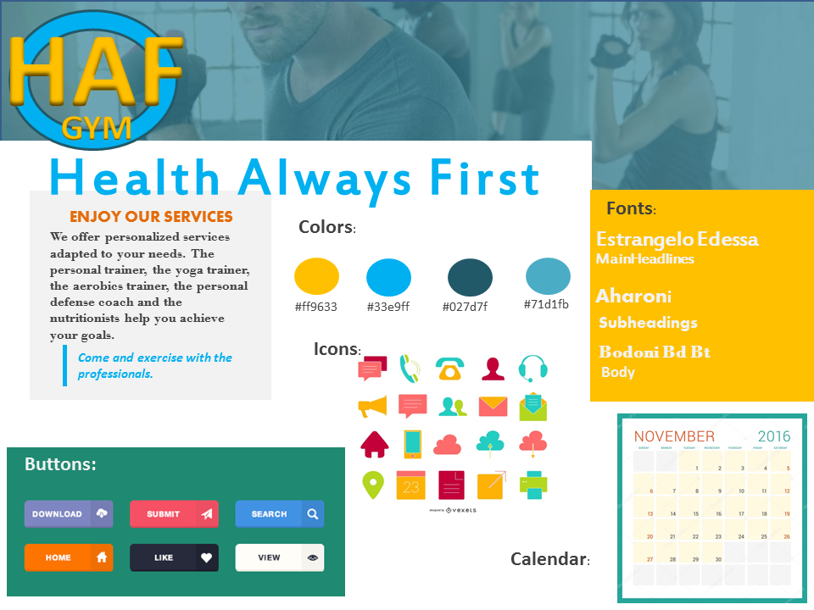

**Usability and Accessibility consideration:**

This is a critical test about the considerations for the success implement of a solution. The success implement of our proposal is given for the satisfaction of users use the application and how it the help them to do faster and better the process and activities daily. All the process to the development is to think about the users.

However, we should think about the accessibility of our solution, understand that the system must be think for the entire users without matter its disability. For this, we try implement ways for these persons, as like screen readers for persons with visual weak that need a digital product whose interface be able to transform text to voice and this way describe the elements that are in the screen.

Other ways take to consider are with the persons with move disable and the hearing impairment. The first need digital products whose interface is integrated to one system of speech recognition. This way the user can access to the sections of the application when say some word in high voice.

The last way named, it is with the people with hearing impairment, they use the eyesight for identify the actions of one interface of a digital product. We must incorporate a functionality that alert to the user about the changes with the use of the color.

**REFERENCES**

Jjg.net (2004). *The elements of user experience: User-Centered Design for the Web.*  [Online] *Available at:* [*http://www.jjg.net/elements/pdf/elements_ch02.pdf*](http://www.jjg.net/elements/pdf/elements_ch02.pdf) *[Accessed Dec. 2018]*

Styletil.es (2018). *Style Tiles: What are style tiles?* [Online] Available at: <http://styletil.es/> *[Accessed Dec. 2018]*

justinmind.com (2018). *How to test a wireframe on users.* [Online] Available at: <https://www.justinmind.com/blog/wireframes-and-user-testing-a-changing-love-affair-2/> *[Accessed Dec. 2018]*

htmlcolorcodes.com (2018). *HTML color codes.* [Online] Available at: <https://htmlcolorcodes.com/> *[Accessed Dec. 2018]*